Name ___________________________________________ Total _____
Date __________
The Odyssey- Calypso, The Sweet Nymph
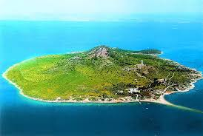

1. What is the name of the messenger god? What does he tell Calypso?

2. Where does Calypso live? Describe her surroundings.

3. How did Odysseus begin to feel about living with Calypso? How does he behave during the day?

4. What does Calypso promise Odysseus?

5. Why does Calypso tell Odysseus he would likely want to stay on the island with her?

6. According to Odysseus, how does Calypso compare to his wife?

7. Where is Odysseus sailing and who makes his sailing difficult?

8. What happens to his raft and where does he land?

